CS5590BD-Big data Analytics and Applications

Lab-03

By

Syamala Reddy Arimanda

16168332

To Build a Java based restful service:

From the link given in the tutorial I installed OEPE Juno in my system. I’ve downloaded jdk 1.7 and jre 1.7 from the internet. In the workbench for developing a web application, I’ve opened Java EE under open perspective which is below window. 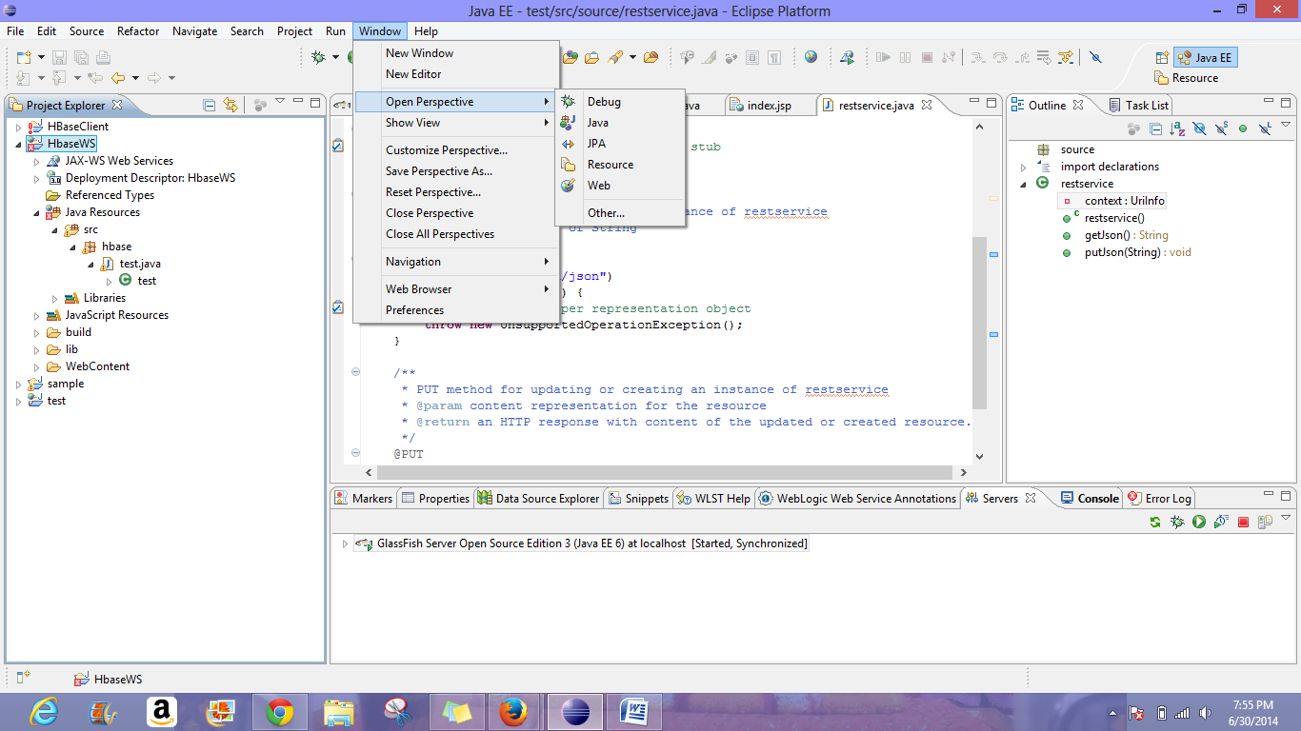

Then,I clicked on the server tab and a new glassfish server is been created. HbaseWS code is imported.After having all the required Jdk files in the library under properties a local directory is given for installing the glassfish.Then the server is started.

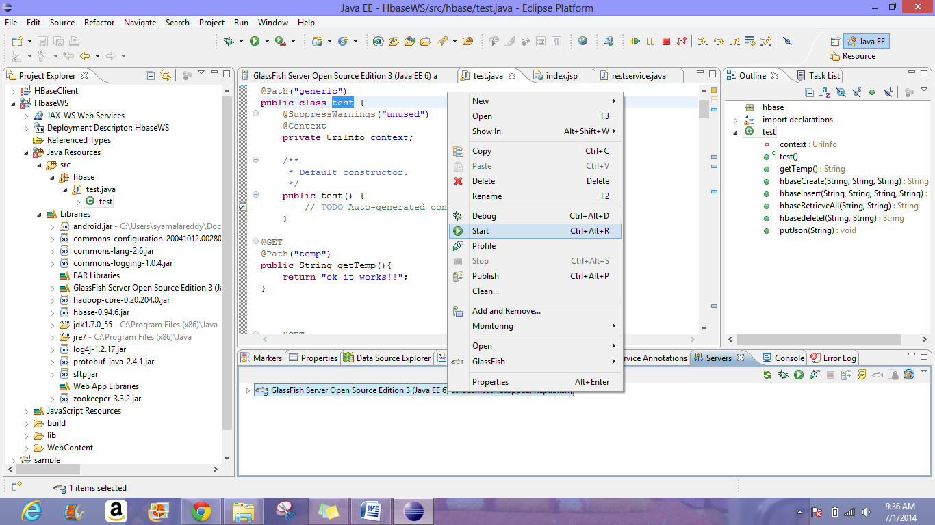

Then command start domain is executed succesfully and the following is displayed in the console.

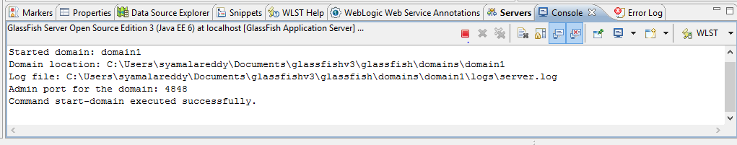

A WAR file is generated by exporting the HBaseWS by selecting a particular path in my system.

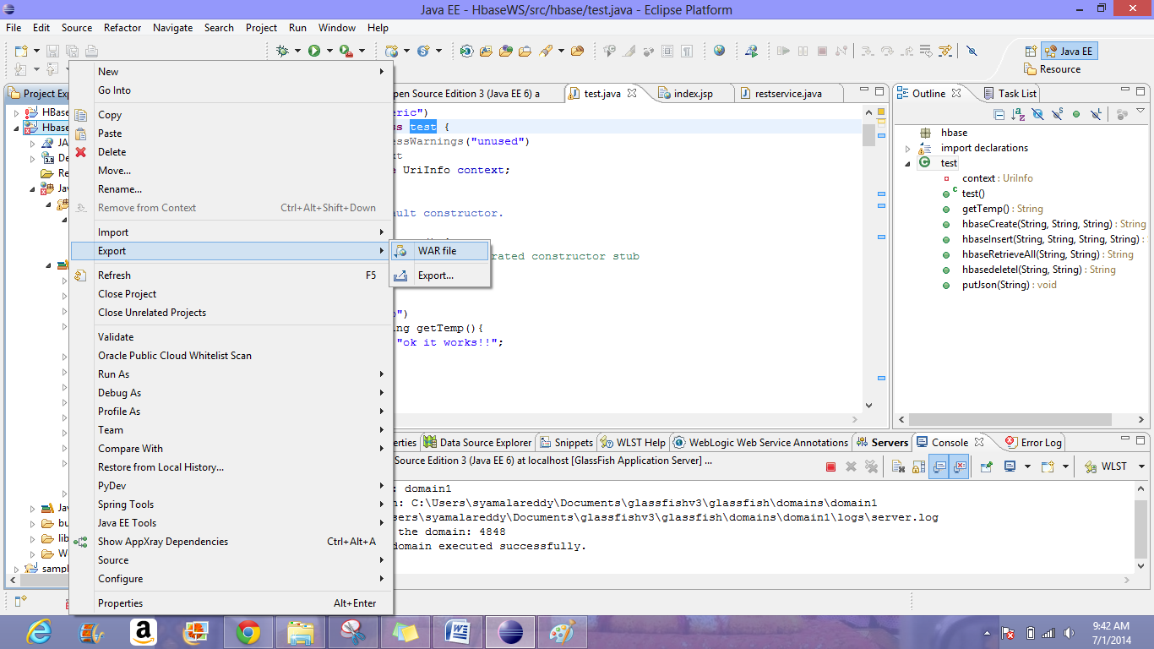

Then this is deployed using deployment assembly which is under the properties of HBaseWS.

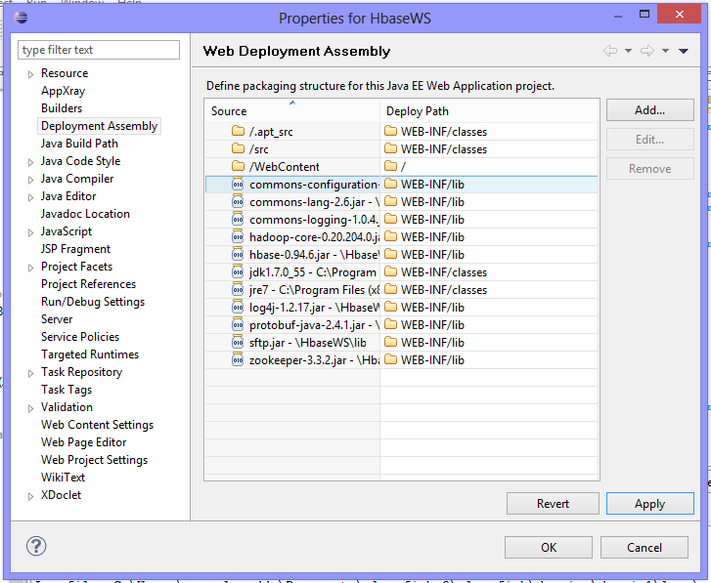

To open the open source edition of the glassfish server url http://localhost:4848/login.jsf is used in the browser.

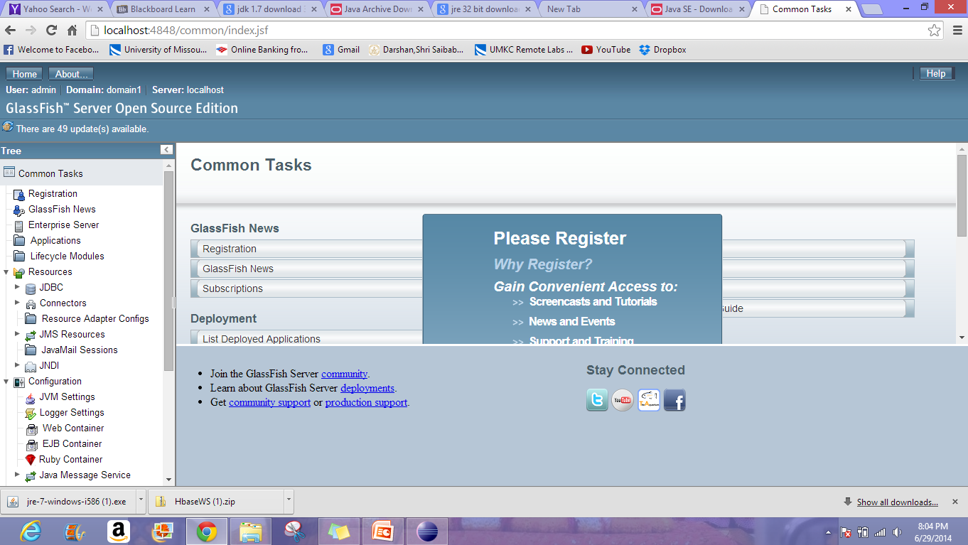

The HBaseWSWAR file which is exported is deployed in the glassfish server.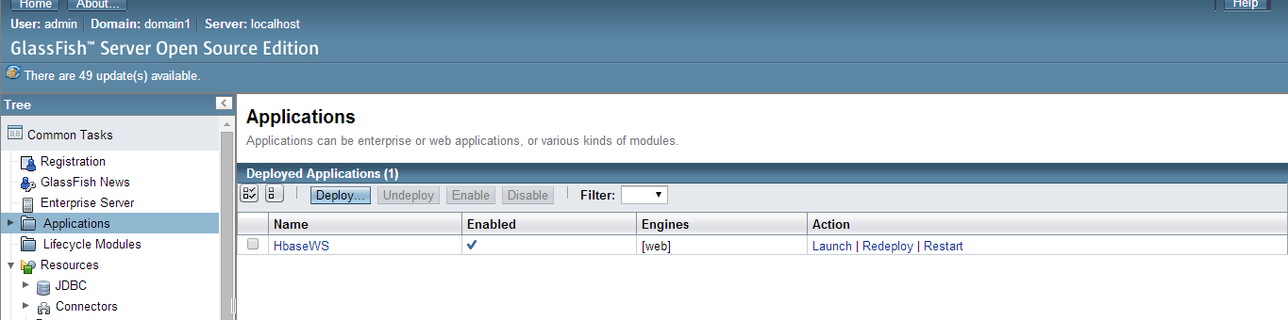

and then it is launched as shown below.

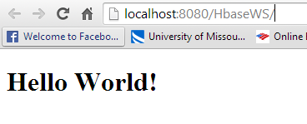

Creating a table:

The command <http://localhost:8080/HbaseWS/jaxrs/generic/hbaseCreate/testTablesyamalaarimanda/GeoLocation:Date:Accelerometer> is given inoreder to create a table.

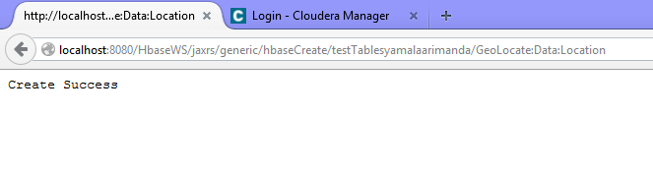

We can view the table created in the Hbase as shown below.

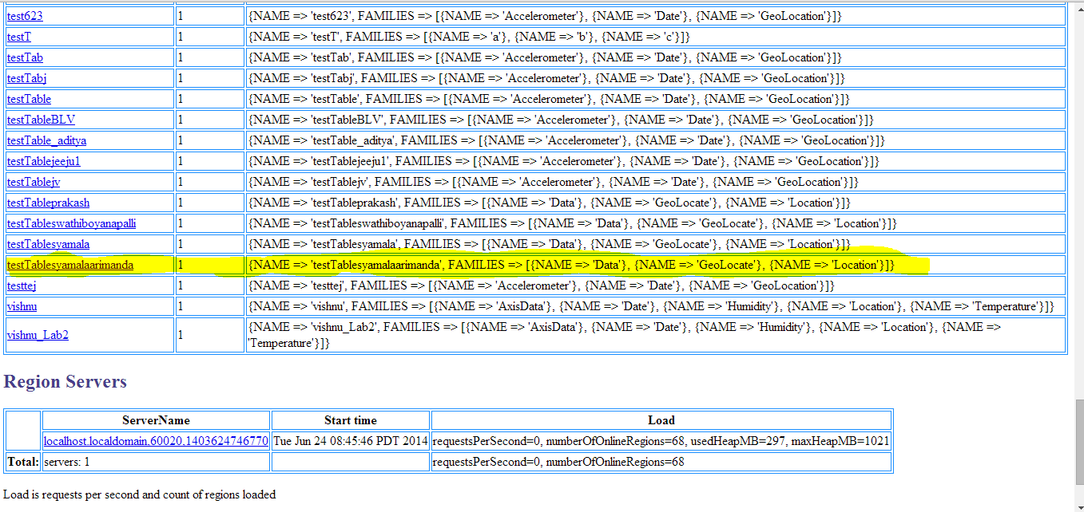

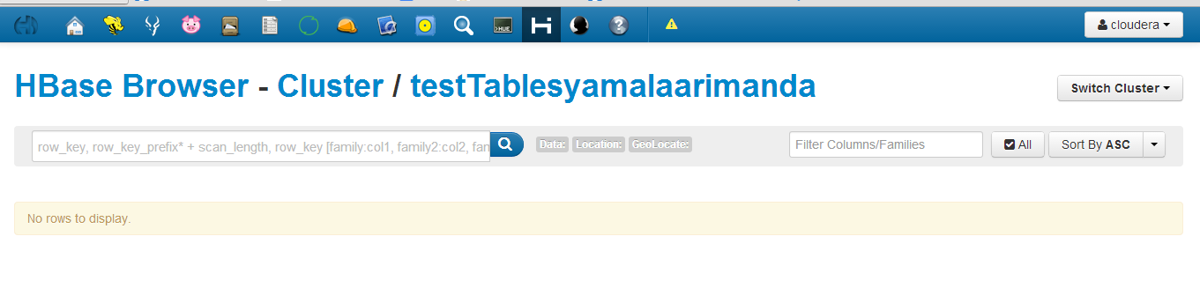

A table is created with columns geolocate,data,location and then the values are inserted into the table from data.txt file as shown below with the command <http://localhost:8080/HbaseWS/jaxrs/generic/hbaseInsert/testTablesyamalaarimanda/C:-Users-syamalareddy-Downloads-data.txt/GeoLocate:Data:Location>

Thus a table with the values in the columnfamilies are created.

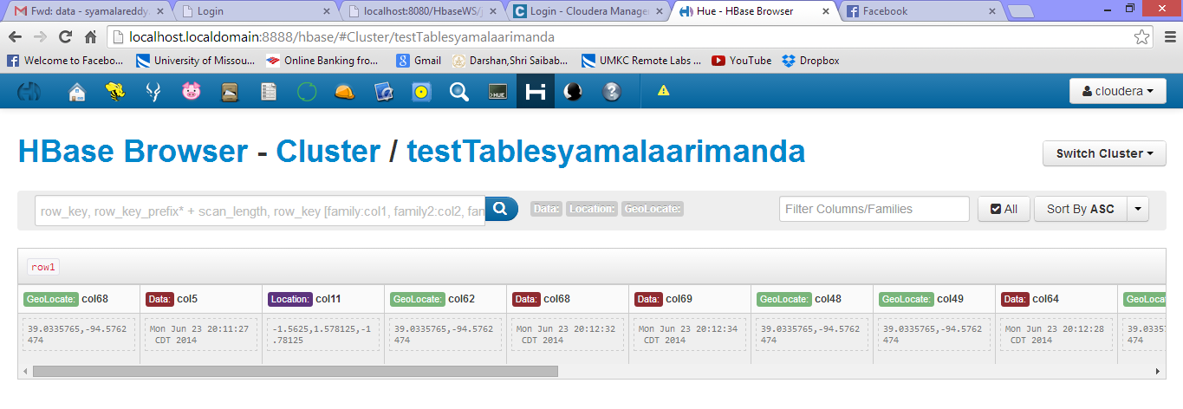

The data is then retrieved using the command <http://localhost:8080/HbaseWS/jaxrs/generic/hbaseRetrieveAll/testTablesyamalaarimanda> as follows

